**Objective of our website:** What does our website say about us? What is the objective we want to convey to them?

* Perhaps that we are friendly/Approachable, passionate, and most importantly **YOUNG & Trendy**. One thing that makes us different is that we are young with a genuine passion. One downfall is our experience, so no point trying to convey that for now. I strongly believe that most parents/children prefer teachers who are young and energetic, then teachers of old when it comes to children. So in our photos, headers, and in our words, we have to try our best to communicate this.

**Colour scheme:** I think it should follow our logo of white background and light blue with a tint of yellow. I would believe these colours will tune better to our intended audience of parents & children. My general feel of the website now is that we are catered to the working professionals or to university students.

**Font**: Definitely needs to change.

**Pages**:

Purple Colour: Headers

Blue Colour: Comments

Black Colour: Content

**1. Landing Page:**

Comments: Move YS’s photo to the “our programs page”. I think we should have a photo either just the kids on the laptop or an instructor with a kid looking at the laptop. Must be smiling. Example below.

Include Logo

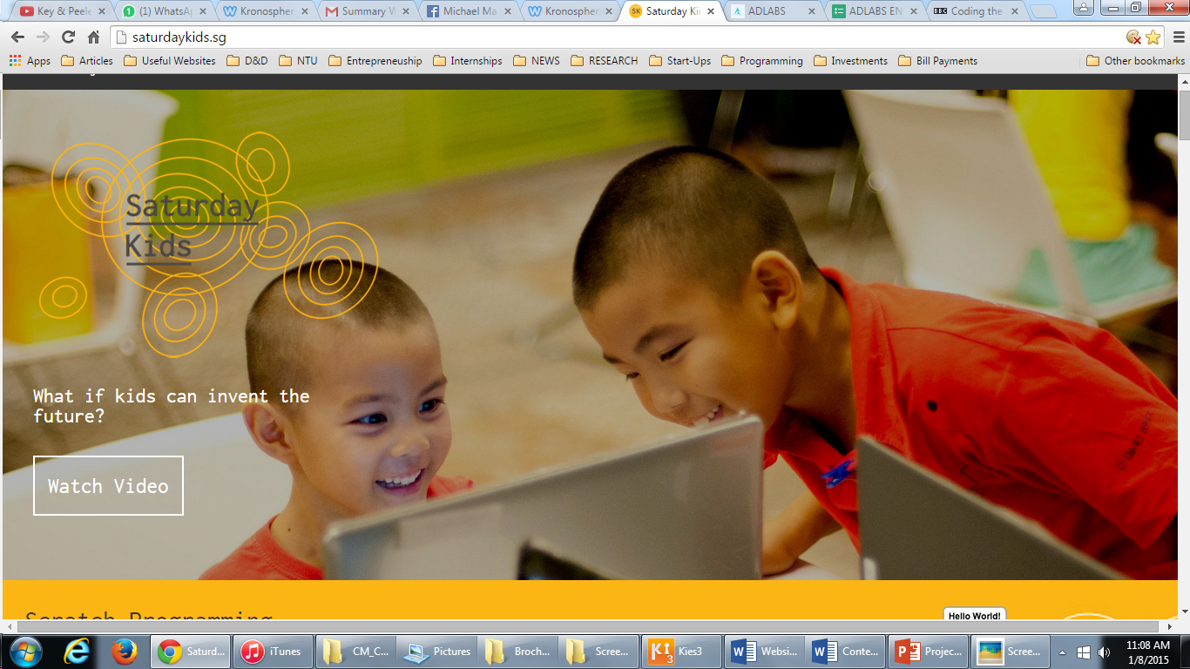

One-liner

Include link to Kanesh’s video

Programming has become the global language of the world. What if your child can’t read it?

OR

Don’t predict the future. Your child can invent it.

**2. Our Programs:**

Comments: Separate the Scratch & Python summary. Include the Scratch & Python logo. Include a “Read more” link after each summary for both Scratch & Python.

I have added the description of what Scratch & Python is. The “Read More” section will go into specific detail about the course outline, age, etc… Don’t link it to the Scratch & Python websites.

**Scratch Programming:** Scratch is a fun programming language that helps young people to learn to think creatively, develop problem-solving skills, reason logically, and develop teambuilding skills. This tool helps them to build their own interactive stories, games, animations, and share their creations with others in a global online community.

Kronosphere offers Basic level Scratch programming classes for children. [Read more]

**Python Programming:** Python is one of the most easy to learn, popular and widely used programming languages in the world. It is quick to pick up whether a first time programmer or experienced with other languages because it was designed with the newcomer in mind. Python is 3-5 times shorter than Java, and 5-10 times shorter than C++. This tool helps young people to create algorithms, search engines, games, and applications.

Kronosphere offers Python programming classes for teenagers. [Read more]

**3. Our Story:**

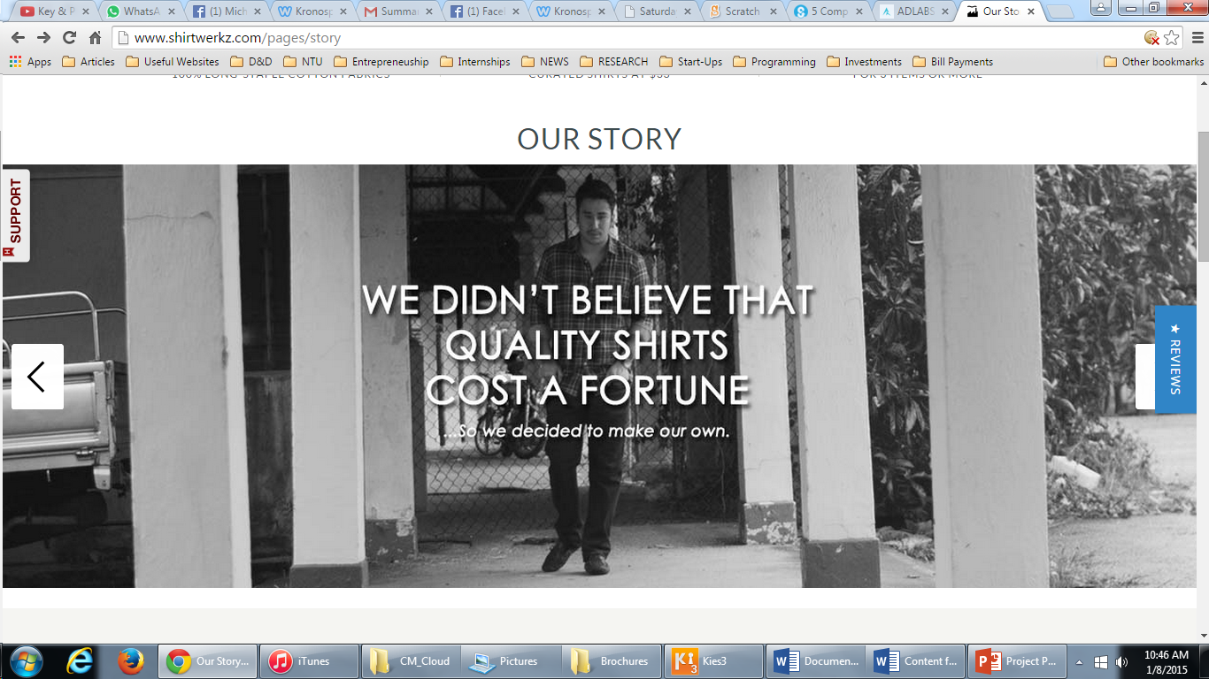Comments: This page can be a bit tricky to design. I envision something like this below for the caption. Once you get the tabs working. I’ll create a “meet the team” section.

**We believe everyone should learn programming. Even you.**

In this digital age, technology has become such an integral part of our lives that we’ve learned to embrace it and take advantage of what technology can do for us.

Programming has always been seen as a difficult task, especially to children and teenagers. But we want to show you that it’s not. Will every job in the future involve programming? No. But it is still crucial that every child learns to code. It doesn’t matter how old you are, what background you come from, or how intelligent you are. We understand the importance of programming as a necessity for the future.

Going through primary, secondary, and university schools in Singapore, we’ve found that the majority of schools still do not properly teach the next generation about computer programming.

**We want change.**

To show the world that programming can be fun, interactive and valuable. To learn to use technology as a tool to become, not just a user, but a creator.

**What is Kronosphere?**

We founded Kronosphere with the duty to provide students with the digital literacy and the computational thinking skills required to survive the future. Empowering them to become creators with technology.

We recognize the importance of coding and hence are passionate about developing techniques to teach it in a more fun and interactive way to children. Our team is young, energetic, and experienced programmers who hold a solid passion to go beyond teaching to become mentors of technology to kids.

**4. Meet Your Makers**

Comments: Photos need to be in high resolution, individual shots. Should be at least half or full body shots. I think passport photos don’t make us approachable or young. Old school trend.

**5. Upcoming Workshops:**

**Workshops:** We teach Scratch & Python in a unique manner with the aim to be interactive, hands-on, and most importantly fun. We believe in engaging the students on a personal level through incorporating character building and mentoring within our pedagogy. We believe it is crucial that every student learns to code. In the future, not knowing the language of computers will be as challenging as being illiterate today.

29th May: ESOL Learning Centre. Penang, Malaysia.

1st – 3rd June: EQ Educare Centre. Penang, Malaysia

3rd August: Macpherson Primary School. Macpherson.

13th – 14th August: Victorious Kidss Educare. Mumbai, India.

31st Aug – 1st September: Python workshop @ NTU

4th – 5th September: Fullmarks Tuition Centre. Tampines.

December: KL

**6. What they say about us?**

Comments: Reviews given by student / parent / teacher (Kaushal help)

**7. Let’s get in touch**

Comments: Have a simple contact form. Have a small section that says Partnership Opportunities with a photo of LCCS & Love-Aid. I’ve included my number as well. I think psychologically, some people avoid using email or contact form because of a lack of response time. I think since we are a start-up, and have time on our hands, I wouldn’t mind putting my number out there for now. In the future we will take it down.

Contact Form: Name, Subject, Number/Email.

Feel free to contact us:

+65 97792199 (Michael)

[hello@thekrono.com](mailto:hello@thekrono.com)

Facebook

**8. Be a part of this movement**

Comments: Have a google sign-up form sheet, but keep it simple. Anything that takes more then 5 mins to fill is a turn off.

Name / Age / Email / Number / Area of interest / 3 words to describe yourself